Chapter 18, Problem 34.

Determine the signal f(t) whose Fourier transform is shown in Fig. 18.38. (Hint: Use the duality property.)

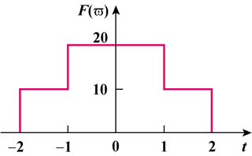

Figure 18.38
For Prob. 18.34.

